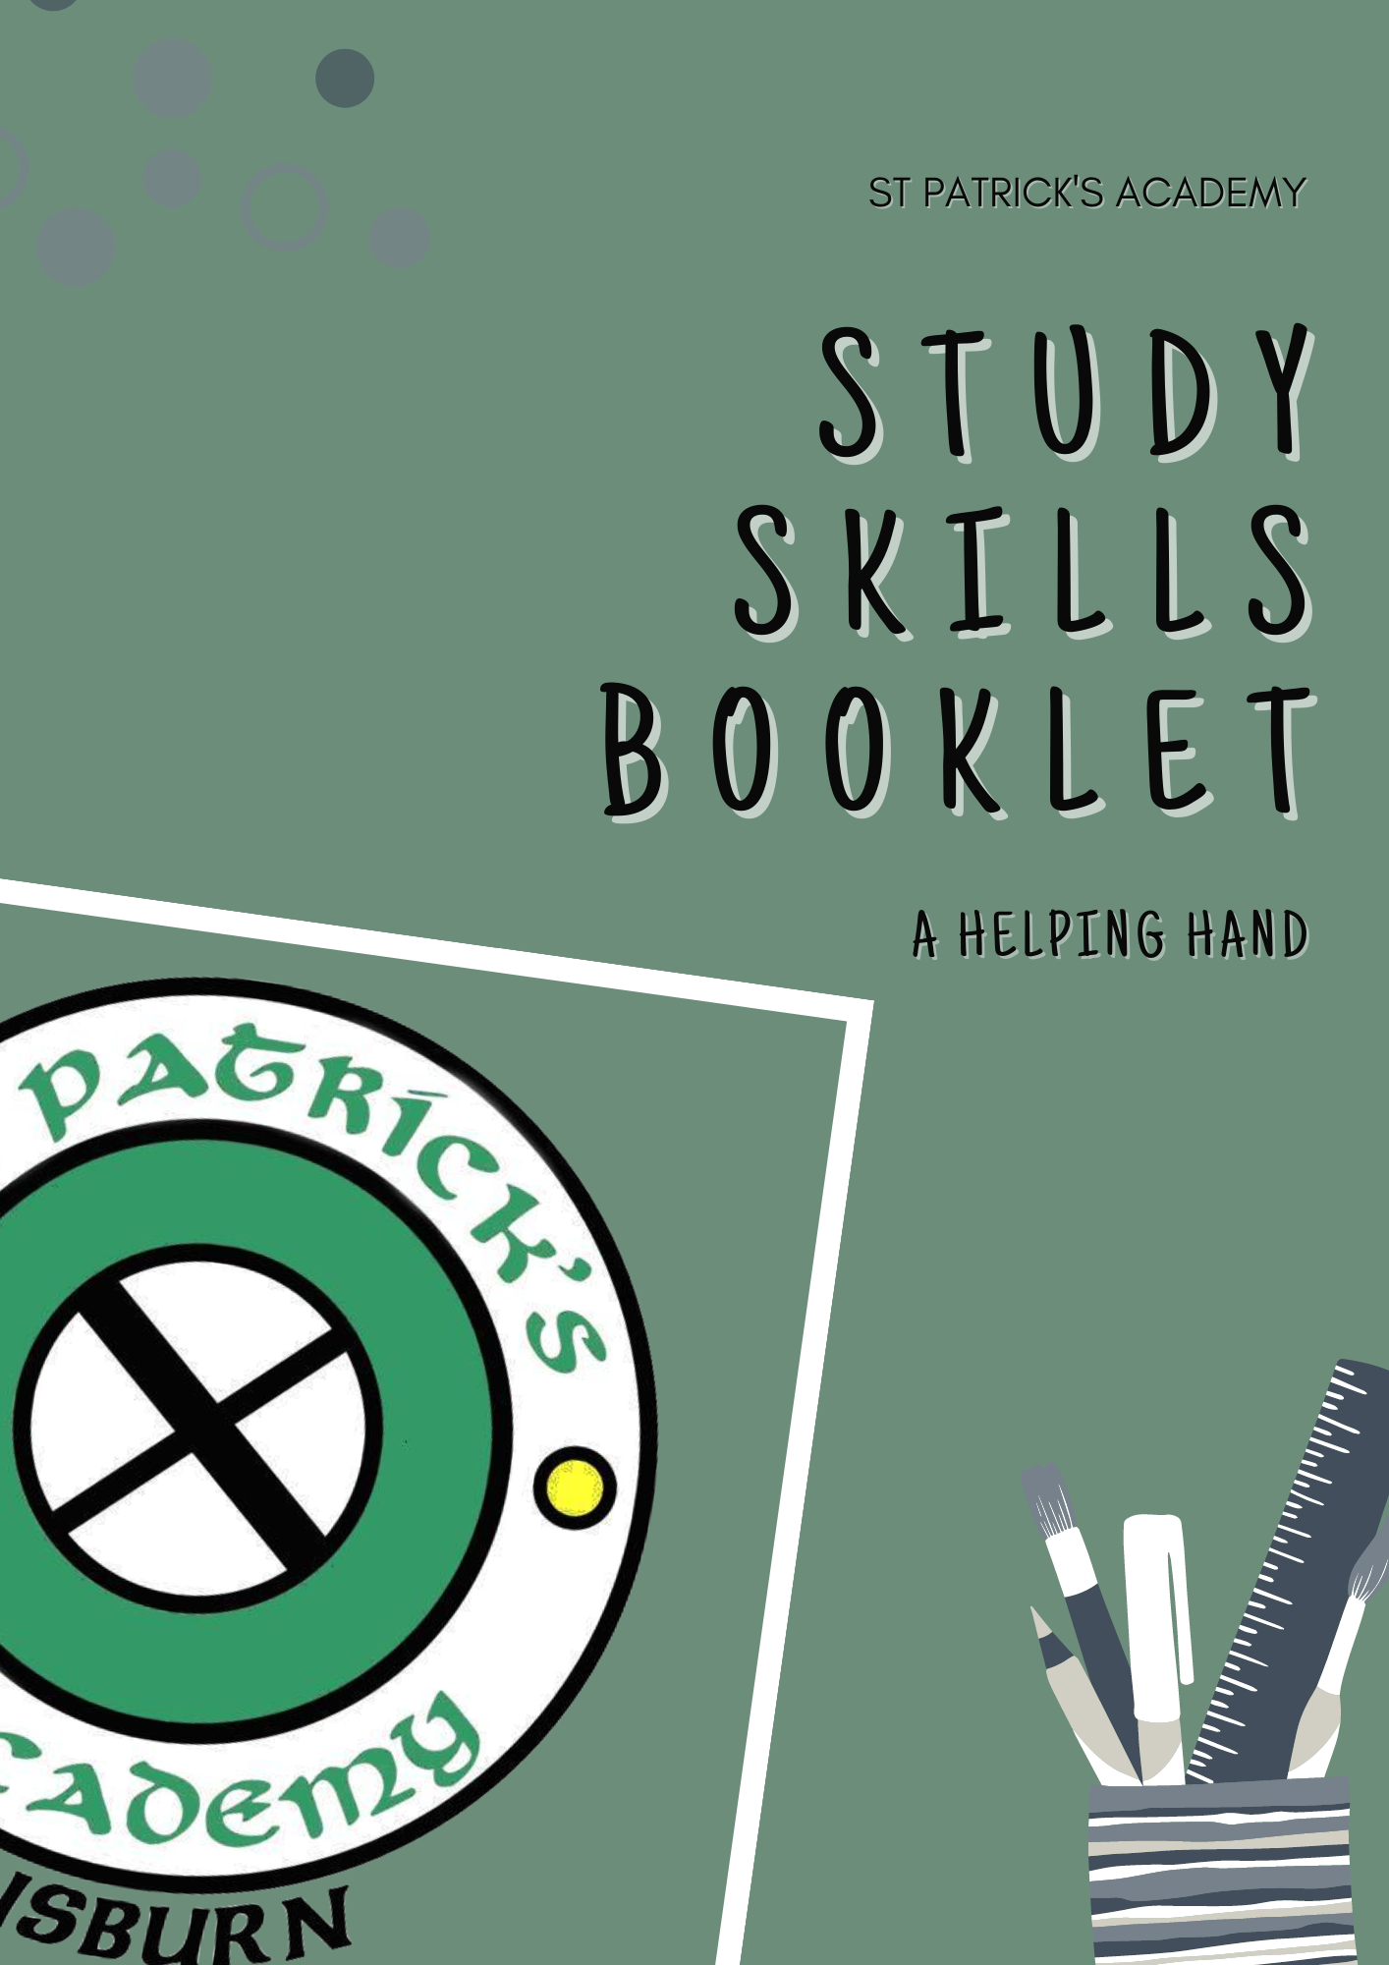
Table of Contents
Study Techniques
Flashcards 2
Mind Maps 3
Textbook Questions 4
Pomodoro Technique 5
Study Environment 6
Teaching Others 7
Exam Questions 8
Listing Steps 9
Diagrams 10
Acronyms and Mnemonics 11
Word Association 12
Storytelling 13
Post-it Reminders 13
Revision Planner 14

Study Techniques

Flashcards

Flashcards can be an extremely beneficial way to help memorise large chunks of information in short periods of time. Flashcards also help in long-term understanding of concepts as they require repetition.

Flashcards are most effective when created by the student themselves as the information can be gathered directly from notes and the process of creating them helps with understanding and begins the initial memorisation process.

Flashcards can be made and studied in many different ways including:
- Paper index cards that have been handwritten
- Cut up pieces of paper or card (colour coordination can also be used here to aid memory)
- Online portals such as Chegg Prep and Quizlet (both are available as apps and online)

Online flashcards can be really effective in saving time as they require the notes to be typed out rather than being handwritten. The flashcards are available online and offline through the app meaning they can be accessed anytime, anywhere for ease of studying- airplane mode can also be turned on to prevent distractions.
Photographs of diagrams can also be uploaded to the flashcard itself.
Chegg prep can be accessed on a laptop or as an app on both apple and android, here flashcards can be created and categorised.
Quizlet is useful for other techniques also as there are options for “learning, flashcards, writing, matching and testing” once the questions have been created.

AVOID USING FLASHCARDS MADE BY OTHER STUDENTS ONLINE. THE INFORMATION MAY NOT BE RELEVANT, UP-TO-DATE OR RELIABLE.

Mind Maps

Mind Maps are beneficial for a variety of reasons. The basic idea behind them is to mirror the brain, hence the idea of “mind map” the information can be laid out in a way that is organised- allowing for a simple way to understand and learn information quickly.

Using colour association, images and curved lines, notes can be recalled more easily, this is especially helpful for visual learners or those with dyslexia.

Mind maps are most effective when notes are simplified so that they can be more easily recalled, your mind can create links between ideas leading to a deeper understanding of the information.

Mind maps can be created using paper and coloured pens or online. Microsoft Word can be used but there are also websites that have a mind map creation tool. Paper mind maps are the most effective as notes have to be written down; if they are simple enough and easy to recall it is possible to quickly draw them up on a scrap piece of paper during test and exam situations to help recall key information.

Keep mind maps safe if they are created early in the year so that they can be used for continuous revision, this is helpful in the leadup to exams.

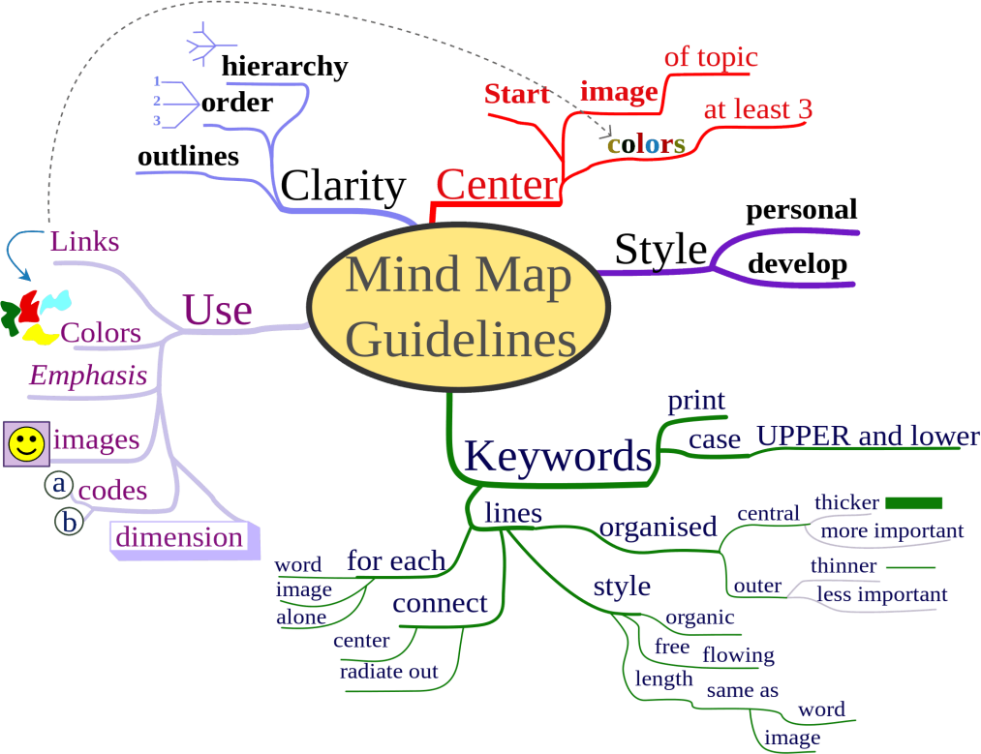

Textbook Questions
As a revision technique textbook questions are often overlooked. In most textbooks there are consolidation questions either throughout or at the end of a key area.
Practicing these questions can help you to understand the material before moving on to more advanced questions, like those in past papers.

Textbook questions can be extremely helpful to understand areas of difficulty as things are often asked and explained in different ways that can be easier to understand. The questions usually relate directly to the notes for that section and the answers are often at the back of the textbook so you can check your progress.

People often believe that while answering questions they can’t use any notes, although this can be helpful if you already understand the information it doesn’t do much to guarantee success if you are struggling. Try answering the questions using your notes to guide you, however, don’t just copy the answer directly from the notes, use them to help you formulate your own answer that you understand and are likely to remember.

If you are not getting the answers right after completing the questions and don’t know where you went wrong make sure you ask for help.

Textbook questions are also useful in tight study times as a key area can be chosen and a few questions completed, these can also be useful as a ‘refresher’ or a ‘warm up’ to do before trying a past paper if you haven’t revised parts of the course in a while.

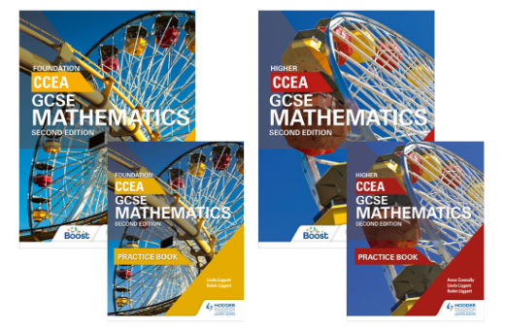

Pomodoro Technique
The pomodoro technique is an extremely useful technique for studying, especially with a large workload or even just to aid you in getting more work done in shorter periods of time.

The pomodoro technique typically consists of a 25 minute burst of continuous studying followed by a 5 or 10 minute break. This is usually repeated 4 or 5 times; if you are continuing to study after 4 or 5 sessions it is recommended to take a 30 minute break before starting again.

This technique is useful in preventing procrastination and is key to time management- it can also help prevent excess stress in the leadup to exams or multiple assessments as time can be set aside for each subject or area that needs revised.
The pomodoro technique may not suit everyone but it does have many benefits. Benefits:
- Increased motivation: less likely to be distracted as you know you only have to
fully concentrate for 25 minutes before you get a break. The pressure of the clock can help too.
- Increased determination: difficult tasks may seem more bearable as again, you know you only have 25 minutes before you get a break. You know you should continue as the clock is ticking which encourages you to push through and complete the task.
- Increased energy: concentrating for 25 minutes while being able to refresh during breaks allows you to be energised for longer.
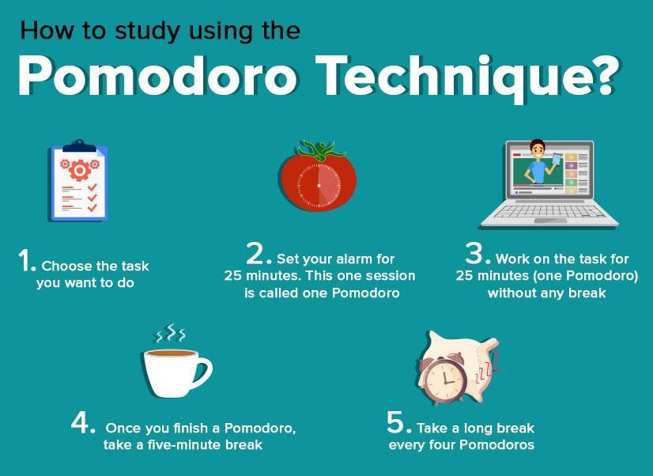

Study Environment

Although it isn’t very commonly thought of, where you study can play a vital role in how you take in the information. Afterschool study classes can be useful for you if you find it difficult to learn from home as it is a familiar educational environment that your brain associates with learning.

Afterschool classes are beneficial as they give you the opportunity to ask questions in a smaller setting (great for people who are shy or have anxiety). It also allows for more one-on-one time with the teacher which can help deepen the understanding of difficult topics or to work through difficult questions with a little more aid.

However, study supports may not always be available but your environment still plays a role in how much you are taking in information. UCAS recommend a variety of things to help you get the best from your study sessions:

- Comfort: ensure you are comfortable enough where you are studying as it allows you to stay focused and motivated for longer.

- Lighting: you are more likely to take in information in a room lit by natural light compared to a dim environment. Try and take advantage of natural light as much as possible by positioning yourself near windows and studying during the day. Natural light has also been shown to boost mood and reduce stress and anxiety while studying. Try and avoid fluorescent lighting as much as possible as these can cause glare and make you feel tired quicker.

- Noise: the level of noise needed depends on the person, but think about where you normally work at your best. Is it under test conditions with the low- level noise of people writing? Is it in a busy environment like a coffee shop or somewhere similar? Is it with background music? Whatever it is mirror this in your study environment to maximise your performance.

- Clutter: minimising the level of mess in your study space can limit the amount of distraction and stress while studying. Keep your study space clean and tidy.

Avoid watching TV, texting or something similar while studying as this is a guaranteed distraction.

Teaching Others

One of the most effective ways to study is by teaching others the information; or at least pretending to. This works as it tests your understanding of the topic and your brain makes links while you are going through the material. This leads to a deepened, long-lasting understanding of the material.

Teaching others is a good way to test your memory on the subject and allows you to explain it in a way that you understand and therefore will be more likely to recall correctly in a test situation.

It doesn’t have to be elaborate or difficult just simply talk through a question or topic, like your teacher would you, and explain to the best of your ability. This is most effective when done without notes as you are forced to recall the information to the best of your ability.

Although it may not always be possible it can be helpful to teach an actual person,such as a parent or a friend, as they may ask questions to test your understanding. Or pair up with a friend who is studying the same subject and take turns teaching topics, that way if you get information slightly wrong it can be identified and corrected and you can both learn.

If it’s not possible to teach someone else and just talking through the information to yourself isn’t working try preparing to teach by making a ‘lesson plan’ or making a powerpoint with the information you want to go over in your ‘lesson’, you are still revising in a less conventional way that has benefits in the long term and can allow you to learn the information.

This is a quick and easy way to revise that isn’t necessarily boring.

This technique was also effective in helping students with dyslexia in understanding information.

Exam Questions

A popular way of studying that allows a feel for what you could be asked in an exam situation. Exam questions can be really beneficial in getting you used to the specific command words that could be asked, such as ‘Describe…” “Explain ” or
“Analyse…” so that there are no surprises during tests or exams. It also allows you to become familiar with the marks awarded for certain question types and what you need to write to pick them up.

In the beginning you can practice exam questions with notes, as long as you don’t copy directly from them. Once you are familiar with the information try the exam questions without any notes but give yourself as much time as you need. You can go through past papers and select questions on the material you are focusing on.

It is important to practice whole past papers before exams under timed conditions in order to work out time management strategies and identify areas you are struggling with. This ensures you are fully prepared for what could come up in the exam.

If you find yourself overwhelmed and struggling with what the questions are asking you to do, try taking a highlighter and highlighting the command word and the key points in the question. This can make it easier for you to identify what exactly it is asking you to do.

Example:

Name the 2 primary colours that would have been mixed to make the orange background of the painting. (2)

Most exam boards like CCEA, have past papers available on their website along with mark schemes.

Listing Steps
Many question types have a process that you have to remember or would be worthwhile remembering. In English based subjects these may be essay plans or in Science and Math based subjects where certain question types require certain steps to be taken. Practice a question and pay close attention to the process, from this create simple steps to follow that are easy to understand and recall.

Once steps have been created they can be put on flashcards and committed to memory to make answering those question types easier.

It is useful to create simple steps that are numbered and have a clear process. It is useful when doing practice questions to write the steps next to the question as and when you are doing them. This aids the memory association of the steps with the question type while also allowing for less questions to be practiced before the concept is fully grasped.

Listing steps is also useful for returning to subjects after long periods of time as the process does not need to be relearned but can just be practiced again to refresh your memory.

If you are struggling to find the steps you follow to answer the question type try writing out in words fully what you would do. Then work on simplifying them as much as possible.

Diagrams

Some people find diagrams really helpful to understand information. Most diagrams relate directly to the material that they are focusing on and can be given by the teacher, found in textbooks or on BBC bitesize to help you visualise the information you are trying to remember. Diagrams can make the information seem more real and concrete in your head, making the information harder to forget.

Simple diagrams are useful to help make complex information easier to understand, whether you create your own diagrams or copy existing ones, they can be created and redrawn under test/exam conditions to help recall difficult material.

It can be helpful to use colour association when learning/drawing diagrams to help commit them to memory.

Diagrams can make a world of difference in helping you study. Don’t let the work go to waste however, simply drawing a diagram once doesn’t guarantee you remember it. Diagrams can be added to flashcards, mind maps or drawn individually beside questions to help aid memory.

Here are some real examples of diagrams from BBC Bitesize pages:

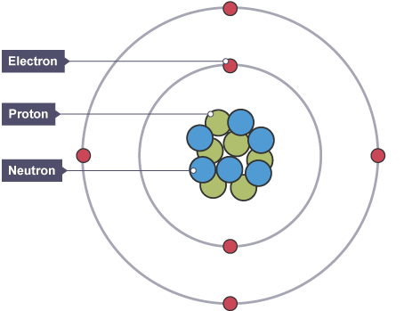
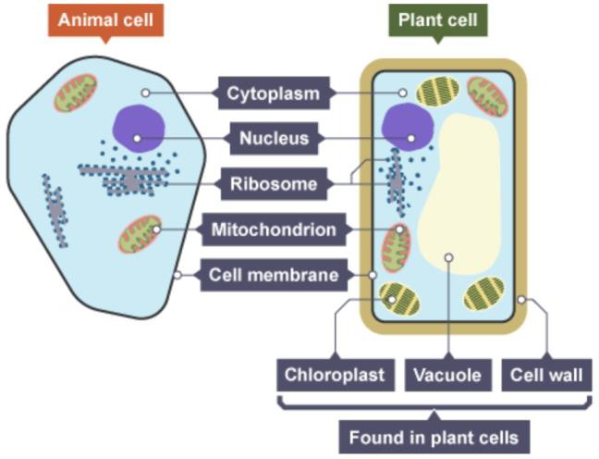

Acronyms and Mnemonics
Acronyms and Mnemonics are useful as a memory technique as they make the information simpler and more interesting to remember. Acronyms and mnemonics are helpful to remember processes or rules, or even essay plans.

If you aren’t sure if something can be made into an acronym try finding the key word or point in the information and taking the first letters, see if they make a word or at least something easy to remember. If this doesn’t make anything memorable try see if you can come up with a mnemonic- these sorts of things are more likely to be memorable if they are funny.

An example of a mnemonic is Big Elephants Can Always Understand Small Elephants, to spell BECAUSE.

Whereas an acronym would be ROY G BIV to remember the colours of the rainbow (Red,Orange,Yellow,Green,Blue,Indigo,Violet)

There are also PEE/PEEL etc. chains that are used in essay based subjects P-point
E-evidence E-explain
L-link

This technique is also used in maths, you may already know BIDMAS. This is the general idea, get something easy to remember and commit it to memory- this could be by writing it on a flashcard, speaking it out loud multiple times or even by teaching it to someone else

Acronyms and Mnemonics are more commonly used than people realise, they are very useful for remembering information quickly. If you are stuck unable to remember something try see if you can use this technique. Make sure you write it down, so that it can be used for future revision.
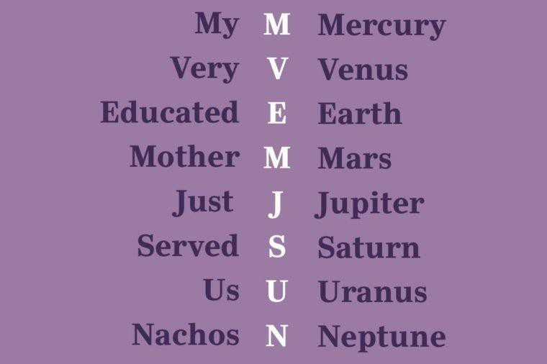
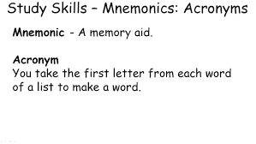

Word Association

Word association is a helpful memory aid to remember difficult and easily forgotten words and phrases. It can be helpful for all types of learners as links can be made through writing, speaking or even drawing pictures. For example to remember the phrase je m’appelle the following pictures could be used.
(Blue) JAY (Mum) MA APPLE

This can be used along with the diagram technique to really help aid memory and can make studying more fun. This technique has also helped friends with dyslexia understand the material they are studying.

Word association does not need to be long winded or complicated, keep it simple and easy to remember. Basic words are best used here as they are more likely to be recalled under stressful conditions, visualising the images in your head can also help the information stick. Even try drawing or printing out the pictures and displaying them in places you know you are likely to see them.

Word association can be studied through mind maps or spider diagrams too, try and find a way that works for you.

You can also use the “around the room” technique too. This works by:

- Choosing a random room whether it be at home or in school.
- Start in one corner of the room and allocate an area of study to this corner.
For example the colour red.
- Then look at the objects in that corner and dedicate a fact to each object, e.g. the computer would be that red is a primary colour, the mirror would be that mixing red and blue make purple, the candle would be mixing red and yellow would make orange and so on.
- Give each corner of the room a different area of study.
- When returning to the information in test/exam conditions you can return to the room in your mind and use the objects in the room to aid your memory.

Storytelling
Storytelling is a simple technique that can be helpful to remember processes as they are unchanging and can just be recalled when needed, similar to mnemonics.
Storytelling is useful as it simplifies long complicated processes, but can also be used for simple processes too.

A really adaptable study technique which is good for people with active imaginations. Storytelling allows you to simplify complicated topics so they can be recalled easier.

Example:

In H2O the hydrogen atoms become a couple and live with oxygen- they live in a street named water.

Putting the stories on flashcards or including them in mind maps with diagrams can all help as a memory aid.

Post-it Reminders

Simple yet effective, post-it reminders can be useful and good as a study technique in a time crunch. Place post-its around the house with questions or words on them, only enter the room or open the cupboard door after answering the question or translating the word.

Really efficient and easily introduced into everyday life even if it may look a little funny, it can also be used as a more visual way to do the ‘around the room’ technique mentioned earlier.

Colour association can help here to recall the information in exam settings, no need for highlighting or coloured pens as different coloured post-its could be used to represent different areas of difficulty. This technique is especially useful for long term memorising and has been helpful for people with dyslexia

